Manual Classification

# Classification

The project seeks to classify *abnormal* patches within retinal images. Abnormal in this instance is defined by an area within the retinal image that is neither a blood vessel, nor the background. Specifically areas that appear darker than the surrounding background. Other abnormalities are not required for this project.

## Blood Vessels

Blood vessels, even if abnormally formed, are considered normal for this project.

All of the below are considered normal.

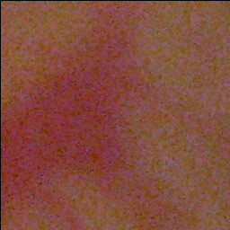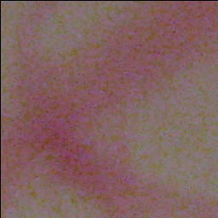

## Background

Retinal backgrounds, including those with small capillaries, are considered normal.

All of the below are considered normal.

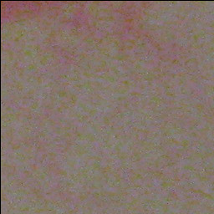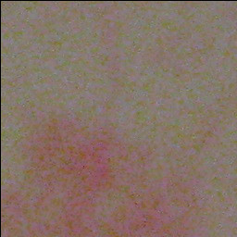

## Abnormal

A background that appears darker than a normal background and is not obscured by blood vessels and does not contain a majority of normal background in the cell is considered abnormal.

All of the below are considered abnormal.

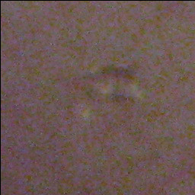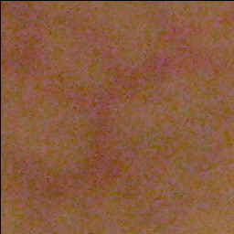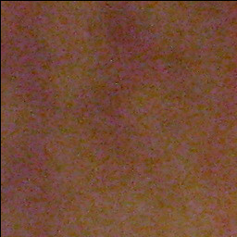

# Matlab

Scripts to generate manual classification have been written and are available on Github at <https://github.com/MonkeyRum/CMP3060M_Item_1>

To generate manual classification data:

1. Download the repository [extract the zip if downloaded as an archive]
2. Download the image data set from Dropbox at
3. Add the repository scripts folder and the image data set to MatLab’s path
4. Call the function *ManuallyClassifyImageDataset* with the following arguments
   1. Full path to image directory with a trailing \
   2. Full path to output directory with a trailing \
   3. 256
   4. 256
      1. Eg ManuallyClassifyImageDataset('F:\backup\Pictures\Imagedataset\', 'C:\manualClassification\', 256, 256)
   5. Left click to toggle abnormal patch
   6. Right click to finish marking
   7. A CSV file will be output into the outDir
5. Upload the manual classification to Dropbox